Hot stuff
Lighting a Bunsen burner
- Place the burner on a heatproof mat.
- Check that the rubber tubing is properly connected to the gas tap.
- Ensure that the air hole is closed.
- Light the match.
- Open the gas tap.
- Hold the burning match just above the top of the barrel.
When you heat substances in the science laboratory, you will most likely use a Bunsen burner.
A Bunsen burner provides heat when a mixture of air and gas is lit.
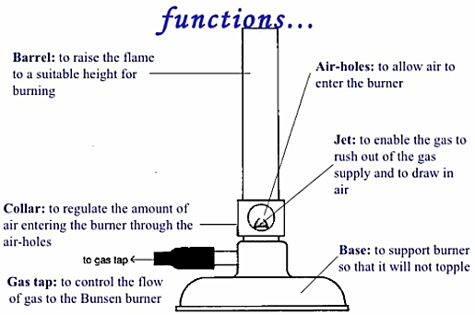

The two flames
The yellow flame of a Bunsen burner is easily seen. So, when the Bunsen burner is not being used for heating, the yellow flame should be used.

The blue flame of the Bunsen burner is much hotter and cleaner but is more difficult to see. The blue flame is used only for heating.

Hot stuff
Lighting a Bunsen burner
- Place the burner on a heatproof mat.
- Check that the rubber tubing is properly connected to the gas tap.
- Ensure that the air hole is closed.
- Light the match.
- Open the gas tap.
- Hold the burning match just above the top of the barrel.
When you heat substances in the science laboratory, you will most likely use a Bunsen burner.
A Bunsen burner provides heat when a mixture of air and gas is lit.

The two flames
The yellow flame of a Bunsen burner is easily seen. So, when the Bunsen burner is not being used for heating, the yellow flame should be used.

The blue flame of the Bunsen burner is much hotter and cleaner but is more difficult to see. The blue flame is used only for heating.

